SIMATS ENGINEERING
CO2_ASSESSMENT TOOL 1: Analytical Problem Solving

COURSE NAME: | Cloud Computing and Big Data Analytics | COURSE CODE: | CSA1522
Name | KEERTHANA.L
Register Number | 192521062

COURSE OUTCOME COVERED
CO2: Analyze virtualization architectures to identify performance and security issues in cloud computing environments. (BL3)
Dave's Taxonomy: Manipulation (Level 2)  Question Count: 5 | Total Marks: 50

Code of Conduct
I KEERTHANA.L-[192521062] (Name / Reg No) certify that this submission is my original work and that I have adhered to the guidelines specified for this assessment.
I understand that any violation of academic integrity rules will result in disciplinary action.
Signature of the student: keerthana.l-[192521062]
Assessment Tasks
Analytical Problem Solving
- Compare Type-1 and Type-2 hypervisors for a cloud datacenter hosting mission-critical applications. Analyze performance, security, and manageability, then justify the better choice.
- A cloud provider must isolate workloads belonging to finance, healthcare, and student portals on the same hardware. Analyze how virtualization architecture supports isolation and identify two major attack surfaces.
- Study the following VM host utilization snapshot and recommend corrective actions: CPU 92%, memory 88%, storage I/O latency 35 ms, average VM boot time 170 s. Explain the likely bottlenecks.
- Analyze how Software Defined Datacenter architecture improves agility compared with a traditional datacenter. Support your answer with compute, storage, and network virtualization considerations.
- A multi-cloud federation project fails due to identity mismatches between providers. Analyze the issue and propose a secure identity and privacy design using federation concepts.

Analytical Problem Solving Rubric

Criteria | Weightage | Level 4 - Exemplary | Level 3 – Proficient | Level 2 - Developing | Level 1 – Beginning
Problem Interpretation | 20% | Interprets all technical requirements accurately | Interprets most requirements correctly | Partial interpretation | Misinterprets the problem
Analytical Reasoning | 25% | Strong reasoning with clear cause-effect analysis | Good reasoning with minor gaps | Basic analysis only | Weak or no analysis
Method Selection | 20% | Chooses highly appropriate virtualization and security concepts | Chooses mostly suitable concepts | Partially suitable concepts | Inappropriate approach
Solution Quality | 20% | Provides feasible and technically sound solution | Reasonable solution with minor issues | Basic solution with limitations | Unclear or invalid solution
Presentation of Analysis | 15% | Well-structured and technically precise | Generally clear | Somewhat unclear | Difficult to follow

Total Marks Awarded:

1.Compare Type-1 and Type-2 hypervisors for a cloud datacenter hosting mission-critical applications. Analyze performance, security, and manageability, then justify the better choice.
Answer:
TYPE-1 HYPERVISOR
Type-1 hypervisor is installed directly on the computer hardware. It does not need any operating system to run. It controls the hardware by itself and creates VMs on top of it.
For Examples: VMware ESXi,Xen
- It Performance is fast because it talks directly to the hardware. There is no extra layer in between, so there is very little delay.
- It security is more secure because there is no full OS underneath. So there are fewer chances for hackers to attack.
- Manageability
Big companies use tools like vCenter to manage many servers at once. It also supports features like moving a VM from one server to another without stopping it.
- it is used in companies, data centers, and cloud services because it can handle heavy and important work.
TYPE-2 HYPERVISOR
Type-2 hypervisor is installed on top of a normal operating system like Windows. It needs the OS to access the hardware.
For Examples: VMware Workstation, VirtualBox
- It Performance is slower because every request has to first go through the host OS before reaching the hardware.
- It Security is less secure. If the host OS gets a virus or gets hacked, all the VMs inside it are also at risk.
- Manageability :It does not have big management tools. It works like a normal software application, so it is hard to use for many servers.
- it is used by students and developers for learning, testing, or running a few VMs on their personal laptop.

2. A cloud provider must isolate workloads belonging to finance, healthcare, and student portals on the same hardware. Analyze how virtualization architecture supports isolation and identify two major attack surfaces.
Answer:
A cloud provider wants to run three different workloads — finance, healthcare, and student portal — on the same physical server. All three are different in nature and all three handle sensitive data, so they need to be kept safe and separate from each other, even though they are physically sharing the same hardware.
How Virtualization Supports Isolation:
- Separate Virtual Machines – Each workload (finance, healthcare, student portal) is placed in its own separate VM. Every VM gets its own virtual CPU and virtual memory that is assigned by the hypervisor, so one VM cannot directly read or access another VM's data, even though they are on the same physical server.
- Storage Separation – Each workload is given its own separate storage volume or space in the storage system. This ensures that files or data belonging to finance are not accessible by the healthcare or student portal workload, keeping data boundaries clear.
- Access Control (RBAC) – Role-Based Access Control is used so that only the correct, authorized admin can access a particular VM. For example, the person who manages the student portal system should not be able to log in or access the healthcare VM, and vice versa.
Two Major Attack Surfaces
- VM Escape – If there is a bug or vulnerability in the hypervisor software, a hacker could use it to "escape" from one VM (for example, the student portal VM) and gain access to another VM (like the healthcare VM). This breaks the isolation that virtualization is supposed to provide, and is considered one of the most serious risks in shared cloud environments.
- Shared Storage Misconfiguration – Since all the VMs may be using the same underlying storage system, if the storage is not configured correctly (for example, wrong access permissions), one workload's sensitive data (such as finance records) could accidentally become visible or accessible to another workload (such as the student portal), even though they are supposed to be isolated.

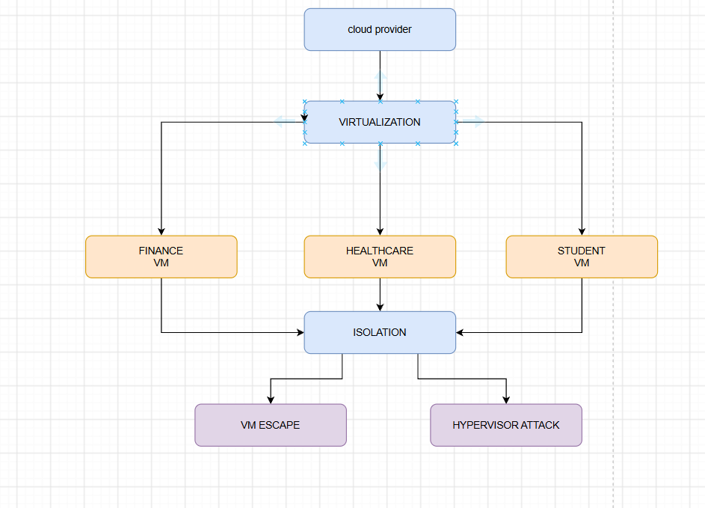
3.Study the following VM host utilization snapshot and recommend corrective actions: CPU 92%, memory 88%, storage I/O latency 35 ms, average VM boot time 170 s. Explain the likely bottlenecks.

VM Host Utilization Snapshot Analysis
Given Data
Metric | Value | Normal Range
CPU Usage | 92% | Below 70-75%
Memory Usage | 88% | Below 80%
Storage I/O Latency | 35 ms | Below 10 ms
Average VM Boot Time | 170 seconds | 20-40 seconds

- CPU (92%) – The CPU is almost fully used. This means VMs have to wait in a queue to get CPU time, which slows down every operation happening on the host, including starting up a VM.
- Memory (88%) – Memory usage is very high and close to the limit. When memory runs out, the hypervisor starts using a technique called swapping, where data is temporarily moved to disk. Since disk is much slower than RAM, this makes everything slower.
- Storage I/O Latency (35 ms) – This is much higher than the normal range (should be under 10 ms). High latency means the disk is taking too long to respond to read/write requests, possibly because too many VMs are using the same disk at once, or because of the swapping happening due to low memory.
- VM Boot Time (170 seconds) – This is the effect/result of all the above problems combined. Since CPU is overloaded, memory is almost full, and disk is slow to respond, the VM takes a very long time to start up completely.
The actions are:
- Migrate some VMs to another host – Move a few VMs to a different, less loaded server using live migration, to reduce the CPU and memory load on this host.
- Add more RAM – Increasing the physical memory of the host will stop the swapping to disk and improve performance.
- Upgrade storage to SSD/faster disks – Replacing slow storage with SSD or NVMe drives will bring down the I/O latency to a normal level.
- Use load balancing tools – Tools like DRS (Distributed Resource Scheduler) can automatically move VMs between hosts to keep the load balanced.
4. Analyze how Software Defined Datacenter architecture improves agility compared with a traditional datacenter. Support your answer with compute, storage, and network virtualization considerations.
Answer:
Software Defined Datacenter (SDDC) vs Traditional Datacenter
A traditional datacenter uses physical servers, storage devices, and network switches that must be manually set up and connected. Adding new applications or scaling up takes days or weeks because the IT team has to configure hardware by hand. This is what makes SDDC far more agile than a traditional datacenter.
How SDDC Improves Agility
- Compute Virtualization – New VMs can be created in minutes using existing hardware and templates, instead of waiting weeks for new physical servers to be purchased and set up.
- Storage Virtualization – All storage is pooled together (Software-Defined Storage) and can be assigned to any VM instantly through software, instead of manually wiring and configuring physical storage arrays.
Comparison Table
Aspect | Traditional Datacenter | SDDC
Provisioning Time | Days to weeks | Minutes
Scaling | Manual hardware addition | On-demand, elastic
Configuration | Manual, per device | Centralized, software-controlled
Compute | Fixed physical servers | Virtual servers created on demand
Storage | Manually assigned to servers | Pooled, assigned instantly via software
Network | Manual switch/router reconfiguration | Virtual networks (SDN), auto-migrated with VM
Flexibility | Low, hardware dependent | High, software controlled
Recovery from Failure | Manual intervention | Automated failover/recovery
Why SDDC:
Since compute, storage, and network are all controlled through software instead of physical hardware, the entire datacenter can be changed, scaled, or reconfigured within minutes. This is the main reason SDDC gives much better agility than a traditional datacenter, which depends on slow, manual hardware processes.

5.A multi-cloud federation project fails due to identity mismatches between providers. Analyze the issue and propose a secure identity and privacy design using federation concepts.
Multi-Cloud Federation Identity Mismatch
A multi-cloud federation lets users log in once and access many cloud providers. Here, the project fails because each provider identifies users differently, so login details don't match properly between them.
Why it happens:
- Different standards – One provider uses SAML, another uses OAuth/OIDC, so they don't understand each other's login info.
- No trust between providers – Each provider trusts only its own system, not the others.
- Different attribute names – One calls it "role," another calls it "userRole," causing wrong access.
- Token mismatch – Login tokens from one provider may not be accepted by another due to different rules.
Proposed Solution:
- Use one common standard (OIDC or SAML) across all providers.
- Set up an Identity Broker in the middle to translate identity info between providers.
- Build trust using digital certificates between providers.
- Use a common naming system so attributes like "role" match everywhere.
- Use short-lived, signed tokens (like JWT) instead of permanent passwords.
- Give users only the minimum access needed (least privilege).
- Encrypt identity data and keep logs of every login/access for security.

